CLEANING ROTA - 2024 
DATE
During week ending
26th January | Fel Kennedy and Christine Rothwell
23rdFebruary | Christine Whitfield and Pat Wood
29th March | Maureen Gill and Dot Hamer
26th April | Fel Kennedy and Christine Rothwell
24th May | Christine Whitfield and Pat Wood
28th June | Maureen Gill and Dot Hamer
26th July | Fel Kennedy and Christine Rothwell
30th August | Christine Whitfield and Pat Wood
27th September | Maureen Gill and Dot Hamer
25th October | Fel Kennedy and Christine Rothwell
29th November | Christine Whitfield and Pat Wood
20th December | Maureen Gill and Dot Hamer
Contact CR if not able to make the date.

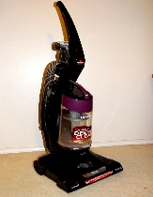
This Photo by Unknown Author is licensed under CC BY-NC-ND

